**PROFESSIONAL PRACTICE IN INFORMATION TECHNOLOGY**

**TASK 1.1P**

1. **Reflection on what I want to learn in this unit and why. How it relates to my future career or personal interests?**

My intention is to deepen my understanding of IT practices along with improving my skills of problem solving in IT. This I believe, will help me keep up with recent technological trends and allow me to integrate well in IT related industries.

I also intend to learn on how to work with others and collaborate on tasks and get comfortable with the tools that enable this collaboration.

1. **Screenshot of group members**

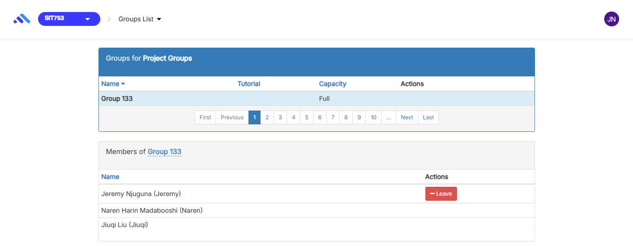

1. **Target grade and why I have chosen the target grade**

*Grade chosen*: High Distinction

*Reason for choosing the grade*: I intend to give my best and ensure that I get to learn to the highest level and acquire exceptional knowledge in this unit and improve skills to the highest level. I believe in my ability to get the highest possible grade.

1. **Intent to participate in the mock interview (form)**

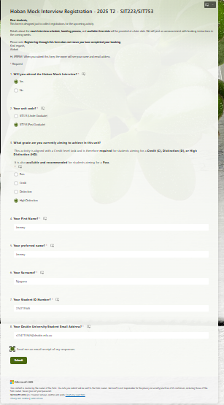

1. **Agreeing to the terms and conditions of the unit.**

I agree that I have read the terms and conditions of the unit and fully understand them.